Redistricting for QGIS

User Guide

Document Version 2.2

|  |  |
| --- | --- |
| Version | Changes |
| 1.0 | * Initial Draft |
| 2.0 | * Added more tips to Equalisation strategy * Definition of urban area |
| 2.1 | * Added additional mouse actions |
| 2.2 | * Add more details on handling shapefiles |
|  |  |

Table of Contents

1 Plugin Requirements 4

1.1 Download QGIS 4

1.2 Installation 4

1.3 Supported file formats 6

1.4 Loading Layers 6

1.5 Attribute Table 6

1.6 Interface Tips 6

2 Plugin Operation 7

3 Example: Analysing Perlis 7

3.1 Feature labels 8

3.2 Equalising Perlis 10

3.3 The EQ Tab 12

4 Equalisation Methodology 13

4.1 Definition of Urban Area 13

4.2 Moving Polling Districts 14

4.3 Equalised Perlis 15

4.4 16

4.5 Equalisation Strategy 17

4.5.1 Clean Start 17

4.5.2 Existing Start 17

4.5.3 Tips 17

4.5.4 Finishing Touches 17

5 Renumbering 18

6 Equalisation Metrics 19

6.1 Circularity 19

6.2 Area size 19

7 Appendix A 20

7.1 Administrative Boundaries (ISCGM) 20

7.2 Google Satellite 20

7.3 Waterways (OpenStreetMap) 21

7.4 Roads (OpenStreetMap) 21

7.5 22

7.6 Digital Elevation model (USGS GMTED) 22

1. Appendix B 23

# Overview

This document describes a plugin (module) created for the open sourced GIS software Quantum GIS (QGIS).

It was created to anticipate the need to equalise constituencies throughout Malaysia quickly if the delimitation proposal of the Malaysian Election Commission is unfair.

Basically, what this plugin does is to present the necessary information to allow a user to quickly equalise both parliament and state constituencies in a Malaysian state simultaneously without the need to increase the number of political seats (constituencies).

As a plugin in QGIS, it allows other layers to be loaded to provide additional information.

The plugin is released under the open-source GPLv2 license.

# Plugin Requirements

## Download QGIS

Go to [www.qgis.org](http://www.qgis.org) and download QGIS for your operating system.

## Installation

The redistricting plugin has not been submitted to the official QGIS repository yet. Until it gets into the official QGIS repository, you will need to specify its location manually to access it. First go to “Manage and Install Plugins”

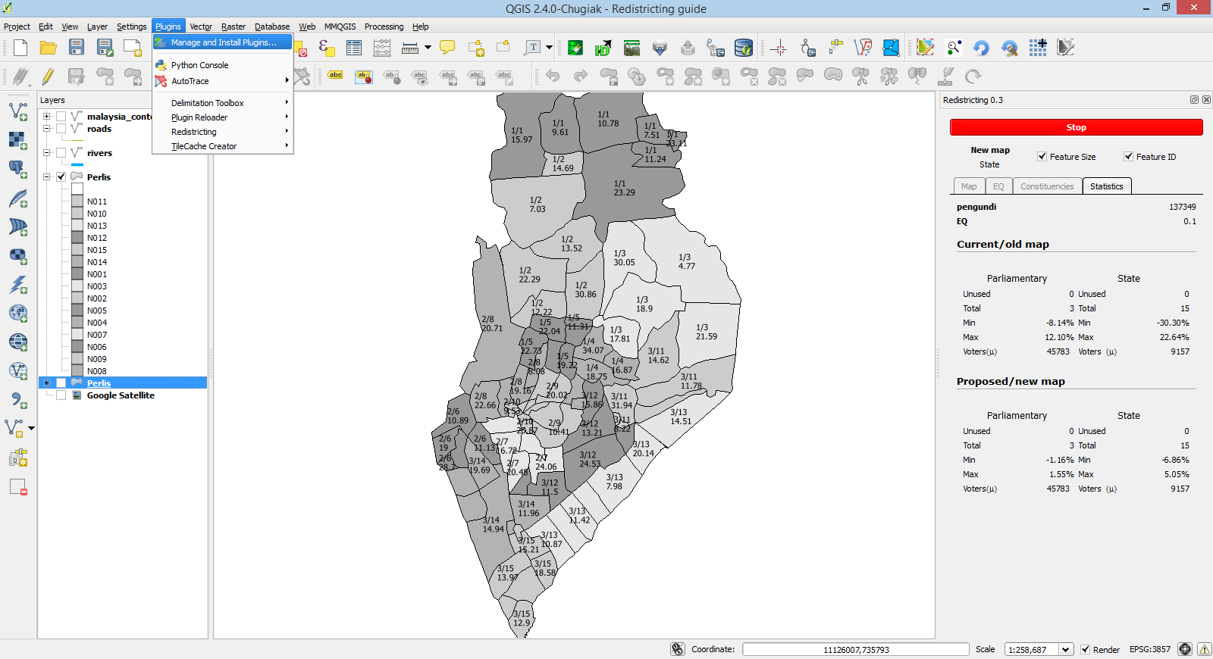

Then add a new plugin repository with the URL <http://www.clearpixels.co.nz/media/qgis/plugins.xml>. Call the repository any name you like, eg. redistricting

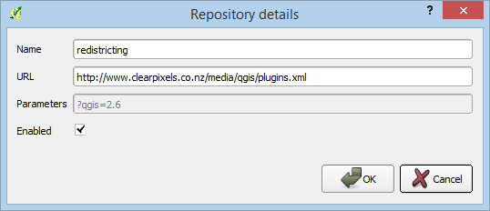

You should then be able to see a plugin called **Redistricting for QGIS**. Install it and then run it by clicking on the option under Plugins from the main navigation bar.

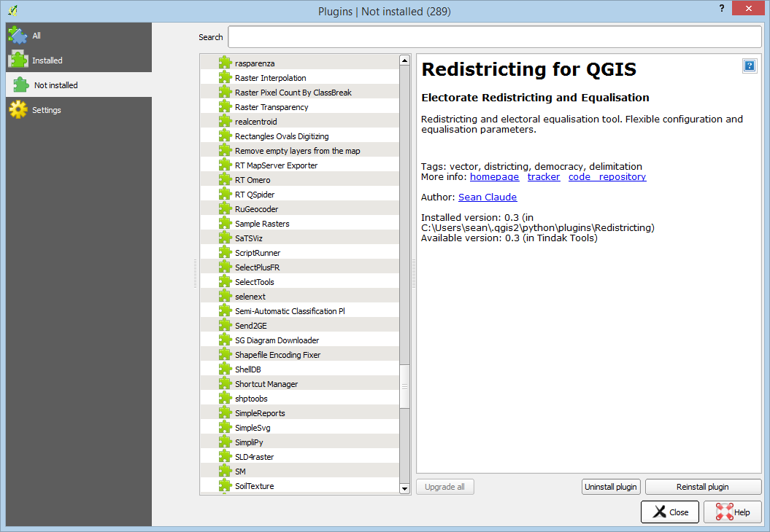

## Supported file formats

The plugin has only been tested with vector layers stored in Shapefiles[1] and PostGIS database vector layers.

## Loading Layers

Using QGIS, load the file you want to analyse via **Layer -> Add Vector Layer …**. This shapefile should contain the state map with individual polling districts as vector polygons (features).

Alternatively, you can drag and drop the .shp file onto QGIS to load it.

You can also drag and drop a zip file containing a shapefile onto QGIS.

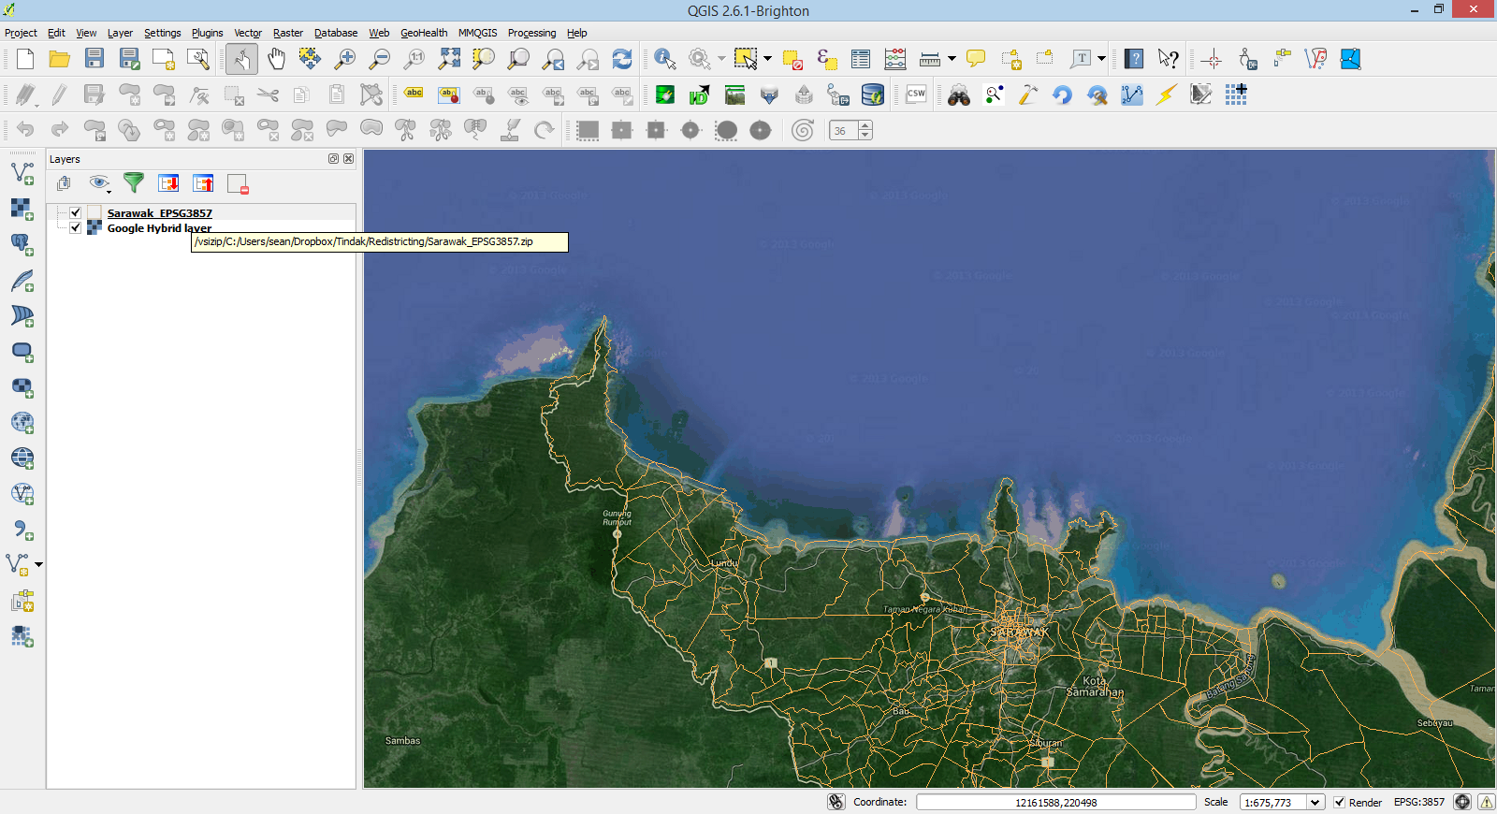

You may however need to set the layer CRS appropriately as QGIS sometimes fail to correctly identify the CRS.

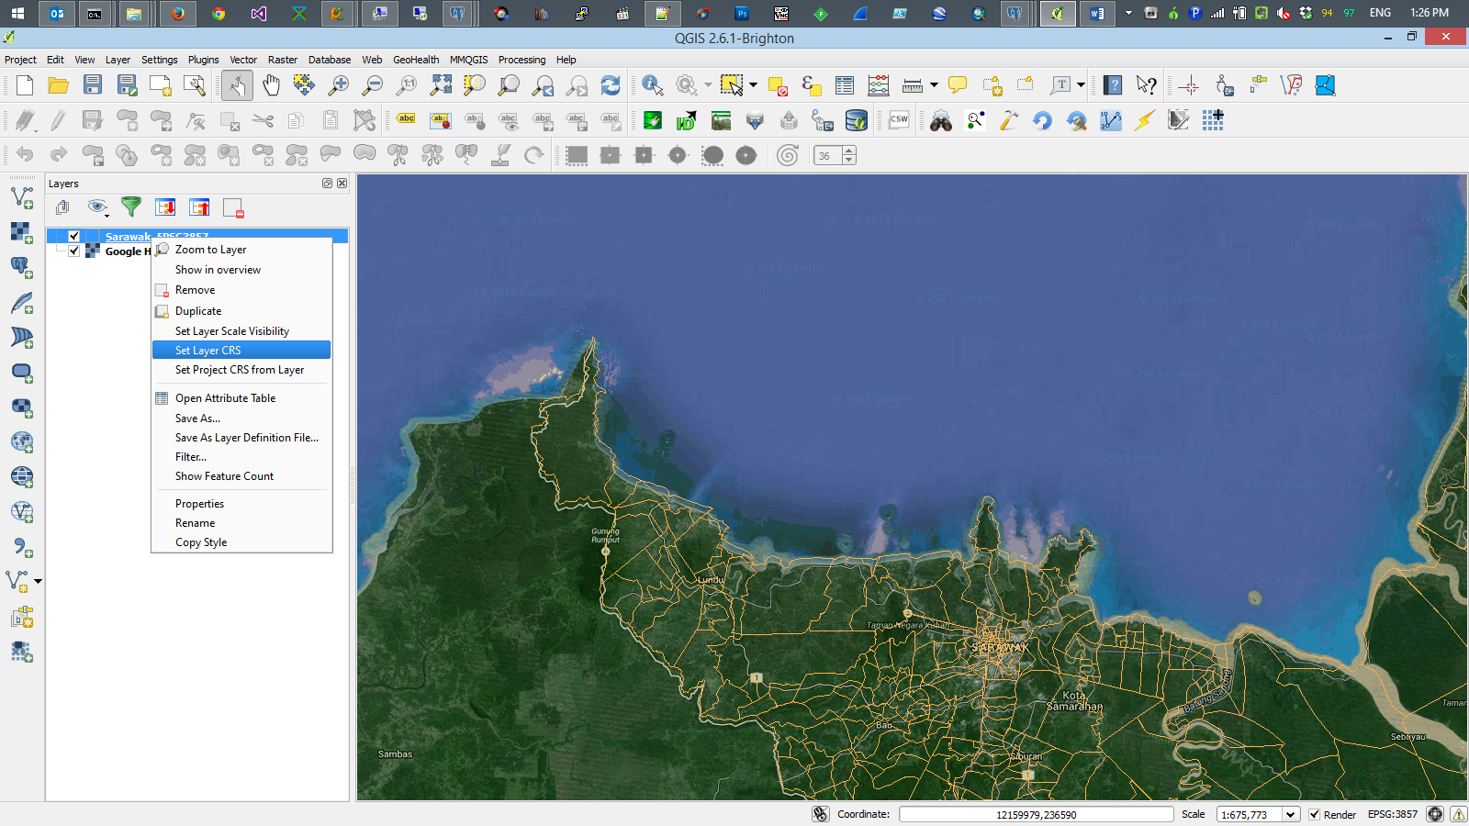

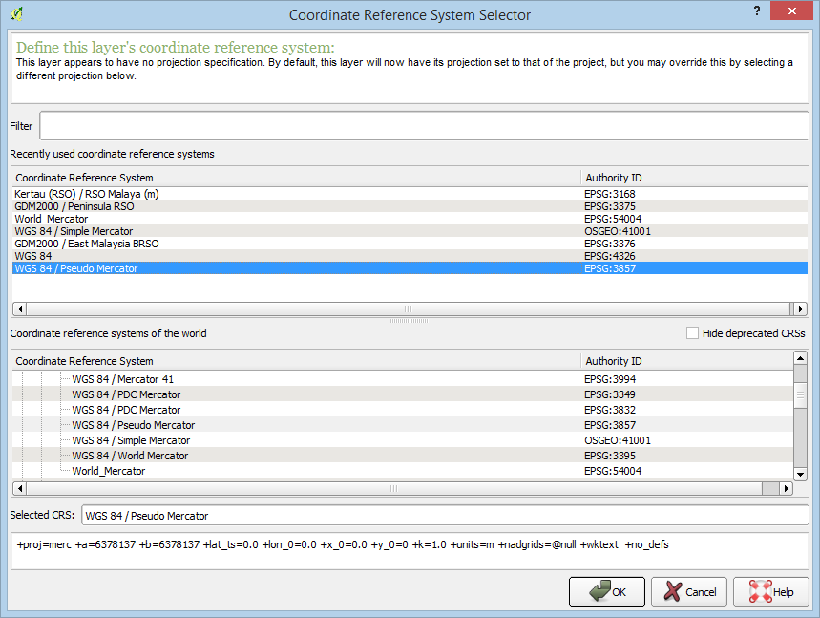

The correct and common CRS is usually EPSG3857[2].

## Attribute Table

Each feature (polling district) can hold additional data about it. These are stored in the attribute table. For the plugin, the attribute table must contain at least the following fields

* 3 text attribute fields to store the unique IDs for the **current or old parliamentary and state seats as well as the polling district**
* 3 text attribute fields to store the unique IDs for the **new or proposed parliamentary and state seats as well as the polling district**
* An integer field for storing the **number of voters** in each polling district

The following depicts the required attribute fields

* For storing the old/current constituencies: parlama, dunlama, dmlama
* For storing the new/proposed constituencies: parbaru, dunbaru, dmbaru
* The field showing the number of voters: pengundi

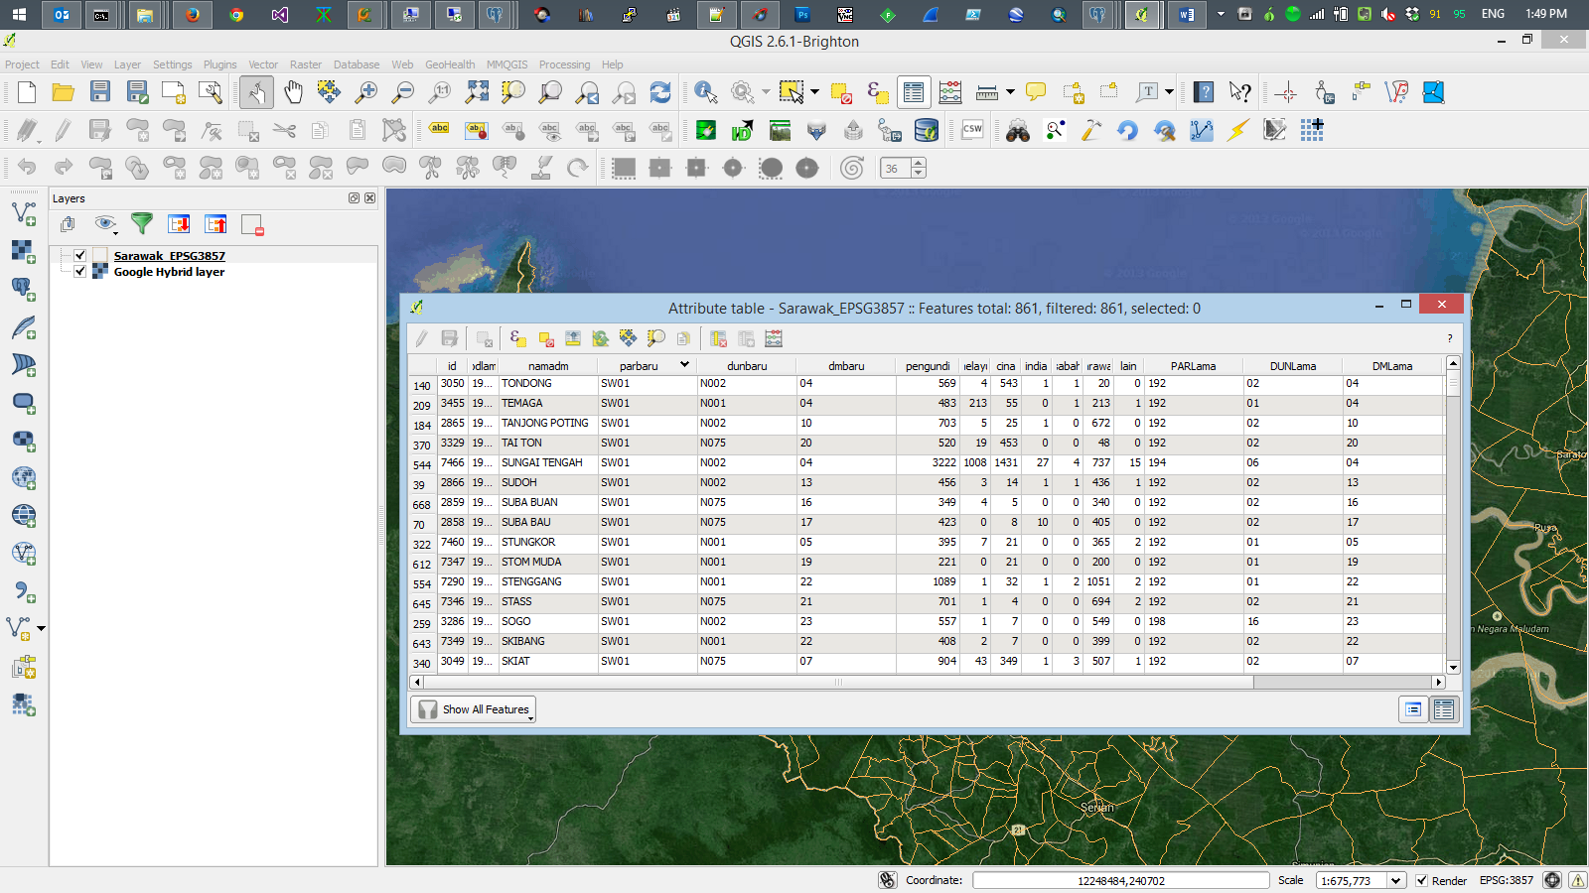

# Plugin Operation

Hover your mouse over user interface (UI) elements of the plugin for a few seconds and tooltips should appear telling you more of what the particular UI element does.

## Example: Analysing Perlis

The following shows the fields we have chosen before pressing the start button. Here we have set the Equalisation Quotient (EQ) to 0.1 or 10%

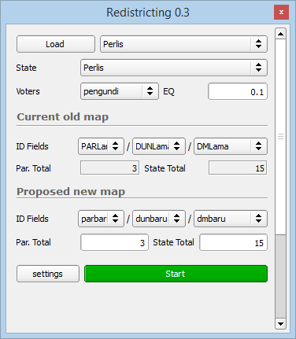

Once the plugin is started, you can perform the following actions on the map with your mouse

|  |  |
| --- | --- |
| Left-click | Select/Unselect a feature |
| Right-click | Get details of parliamentary/state constituency the polling district is currently in |
| Right click and hold | Pan map[3] |
| Left click and hold | Multi select |
| Double right click | Select/Unselect the entire parliamentary constituency |
| Double left click | Select/Unselect the entire state constituency |

After pressing start, you should get something like the following image 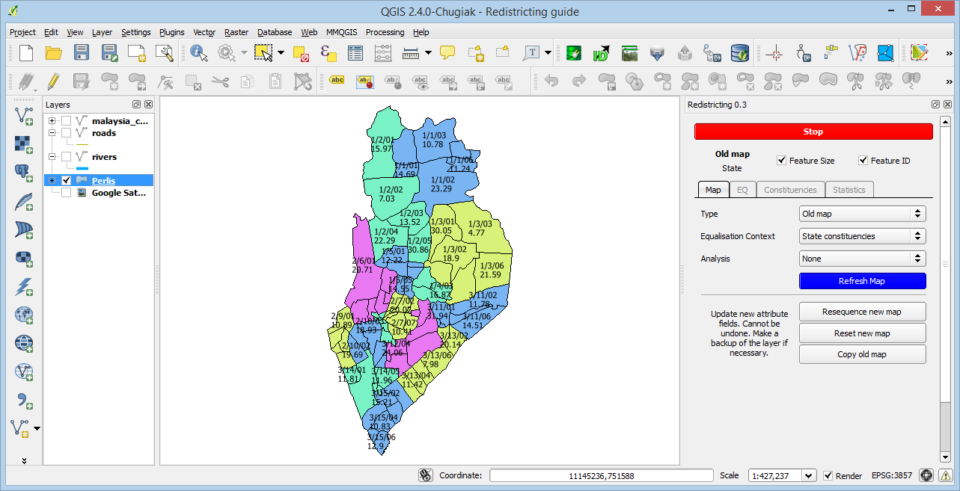

This shows the different state constituencies in Perlis coloured to show polling districts (features[4]) in the same state constituency. This is based on the old map.

You can change the various dropdown boxes to switch between old and new maps or whether you want to balance state or parliamentary constituencies.

Press the refresh map button to redraw the map based on the selected choices.

## Feature labels

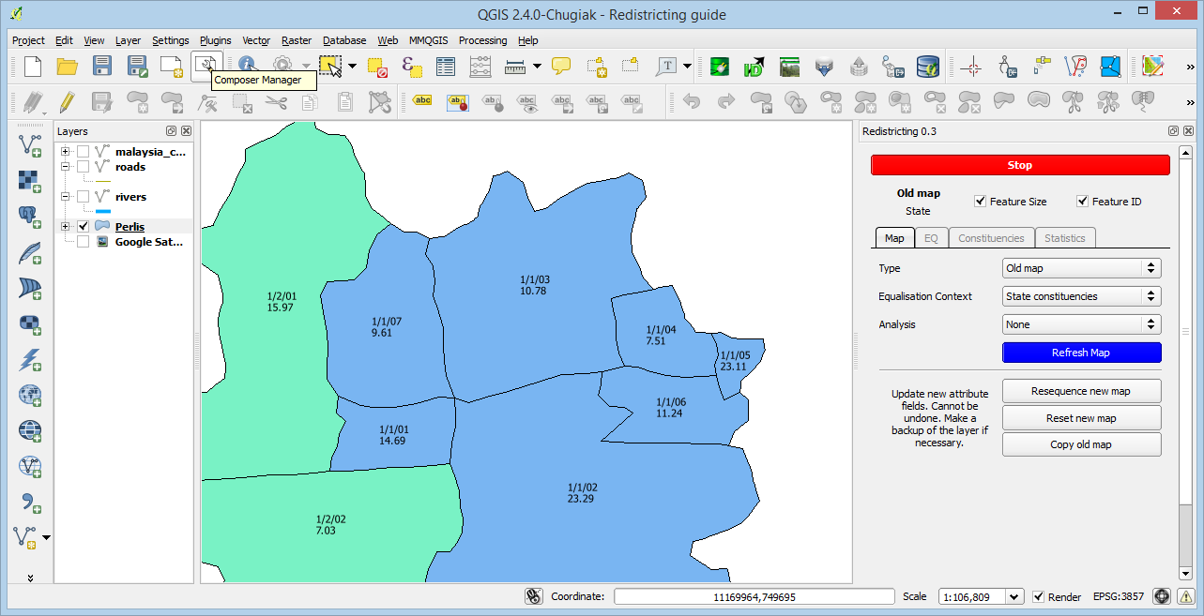

Each feature has a label, which can be turned on and off. For the above feature,

* **1/1/03** corresponds to the values **<parliamentary ID>/<state ID>/<polling district ID>**
* **10.78** is the relative size of the polling districts in percentage. No. of voters/average constituency voters. Constituency here may mean state or parliamentary.

## Equalising Perlis

To minimise the number of changes necessary to equalize the constituencies, we will start by equalizing based on the current map. Do this by pressing the “copy old map” button to copy the current ID values over to the new ID fields.

**All updates will write to the layer directly. BUT only the 3 new ID fields will be written to.**

Select the following options and hit refresh

|  |  |
| --- | --- |
| Type | New map |
| Equalisation Context | State constituencies |
| Analysis | Equality |

And you should get the following.

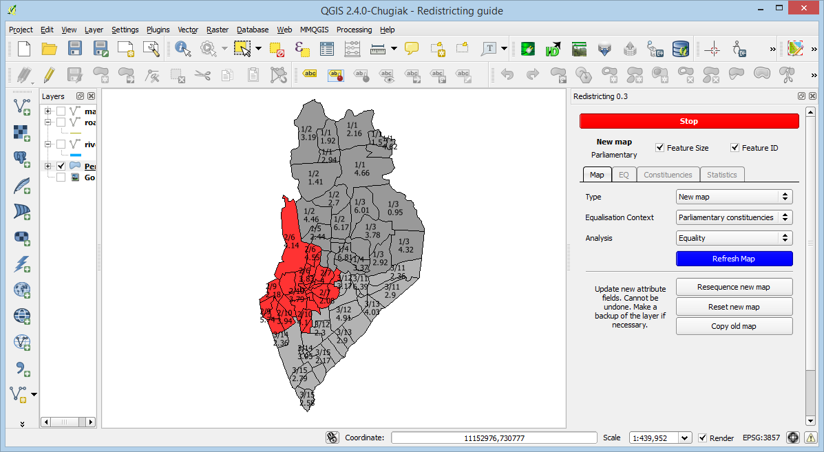

The different colours gives the following information.

|  |  |
| --- | --- |
| Grey | Constituency is within the specified EQ |
| Blue | Constituency is more than 10% (EQ) smaller than the average constituency size |
| Red | Constituency is more than 10% (EQ) larger than the average constituency size |

The different shades is used for identifying the different state or parliamentary constituencies. **Currently, they do not represent size, ie. a constituency with a deeper shade of blue does not mean it is smaller than one that is lighter.**

**TIP:** You can press the “**refresh map”** button repeatedly to redraw the layer with a slightly different shade.

From the map, we can see that par 2 is too large while the others are OK. If we change our equalisation context to state, we get the following

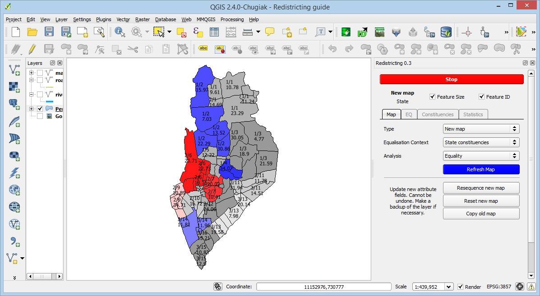

Here, we show where the large and small state constituencies are. The large ones are in PAR 2 and the small ones are in PAR 1 and PAR 3.

To get a list of PARs and STATEs sizes, select the constituency tab and click list constituencies. You can click on each row to highlight the selected state constituency. Each column is sortable by clicking on the column title.

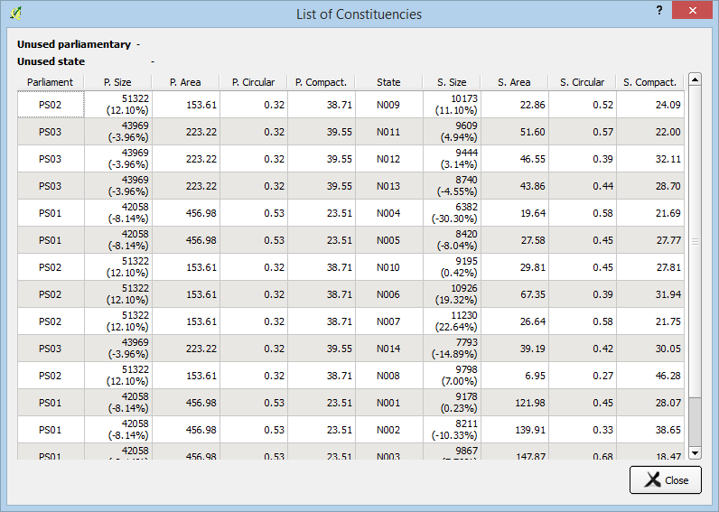

## The EQ Tab

Alternatively, you can **right click on a feature**. If we right click on the top left feature in blue (1/2), the plugin will display the EQ tab and selects the appropriate dropdown values, giving you details of the parliamentary and state constituencies it belongs to.

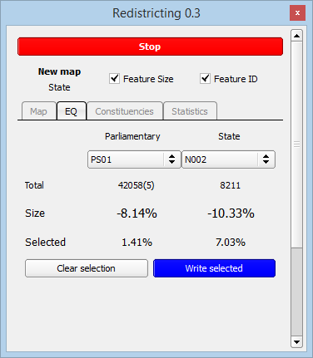

**While equalising, you will spend most of your time here.** The following information can be gathered from the information shown above

* We are currently equalizing state constituencies
* PS01 (PAR 1) has 42058 voters and contains 5 state constituencies
* N002 (STATE 2) has 8211 voters
* PAR 1 is 8.14% smaller than the average parliamentary size
* STATE 2 in PAR 1 is -10.33% smaller than the average state
* Some features are currently selected which adds up to a size of 7.03% of the average state constituency size or 1.41% the average size of a parliamentary constituency

**TIP:** Right click on features in constituencies around the constituency you want to update to quickly identify small or large constituencies when equalising. For example, a smaller neighbouring constituency means you can move polling districts to it from oversized constituencies. While a larger neighbour means you can take polling districts from it to be allocated to undersized constituencies.

While equalising, we may wish to have access to additional information like natural boundaries like roads, rivers and administrative boundaries. These layers can be loaded in QGIS and layered on top of our working layer. See the Appendix for a few examples.

# Equalisation Methodology

The following except is taken from the Thirteenth Schedule of the Malaysian Federal Constitution.

*2. the following principles shall as far as possible be taken into account in dividing any unit of review into constituencies pursuant to the provisions of Articles 116 and 117—*

*(a) while having regard to the desirability of giving all electors reasonably convenient opportunities of going to the polls, constituencies ought to be delimited so that they do not cross State boundaries and regard ought to be had to the inconveniences of State constituencies crossing the boundaries of federal constituencies;*

*(b) regard ought to be had to the administrative facilities available within the constituencies for the establishment of the necessary registration and polling machines;*

*(c) the number of electors within each constituency in a State ought to be approximately equal except that, having regard to the greater difficulty of reaching electors in the country districts and the other disadvantages facing rural constituencies, a measure of weightage for area ought to be given to such constituencies;*

*(d) regard ought to be had to the inconveniences attendant on alterations of constituencies, and to the maintenance of local ties.*

## Moving Polling Districts

The most basic operation that we need to know is how to allocate a polling district to a constituency. This involves 2 things

* specifying the PAR and STATE IDs that we want to update
* selecting features to write these IDs to

**If a PAR or STATE ID is currently unassigned, it will be highlighted green in the dropdown list.**

In our example, we wish to move the bottom red polling district (size 17.8%) to the state constituency 3/14

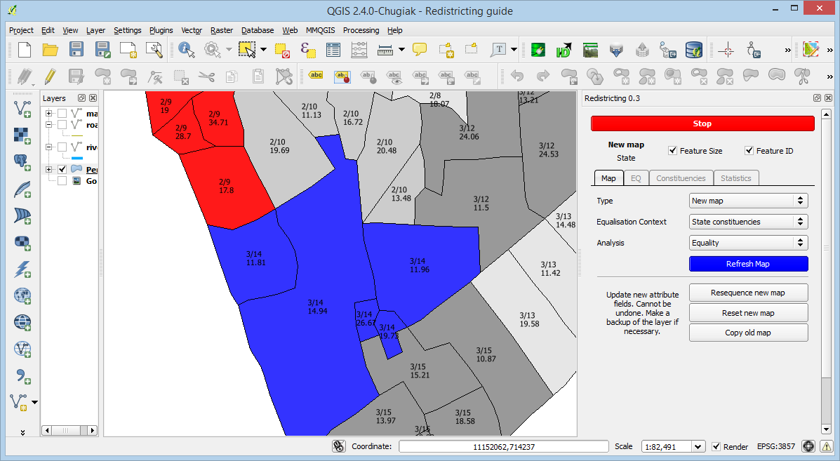

To do this, do the following

1. Right click on any feature on the map that is currently in 3/14, to switch focus to it. The EQ tab will be displayed when you do this.
2. Left-click on the feature we want to move to select it

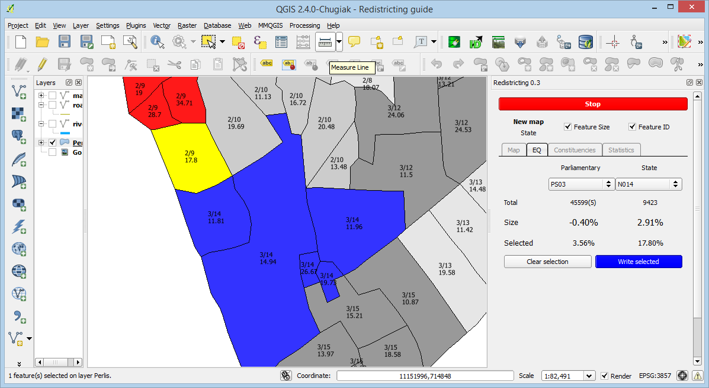

Notice how the selected values now shows the size of our selected polling district? The value of size has also been updated. This shows the size of 3/14 if our selected feature was to be included.

1. Click the button “**write selected**” and you will be asked to confirm your action
2. Click yes

Now, both STATE 14 and STATE 9 is within the EQ of 10%.

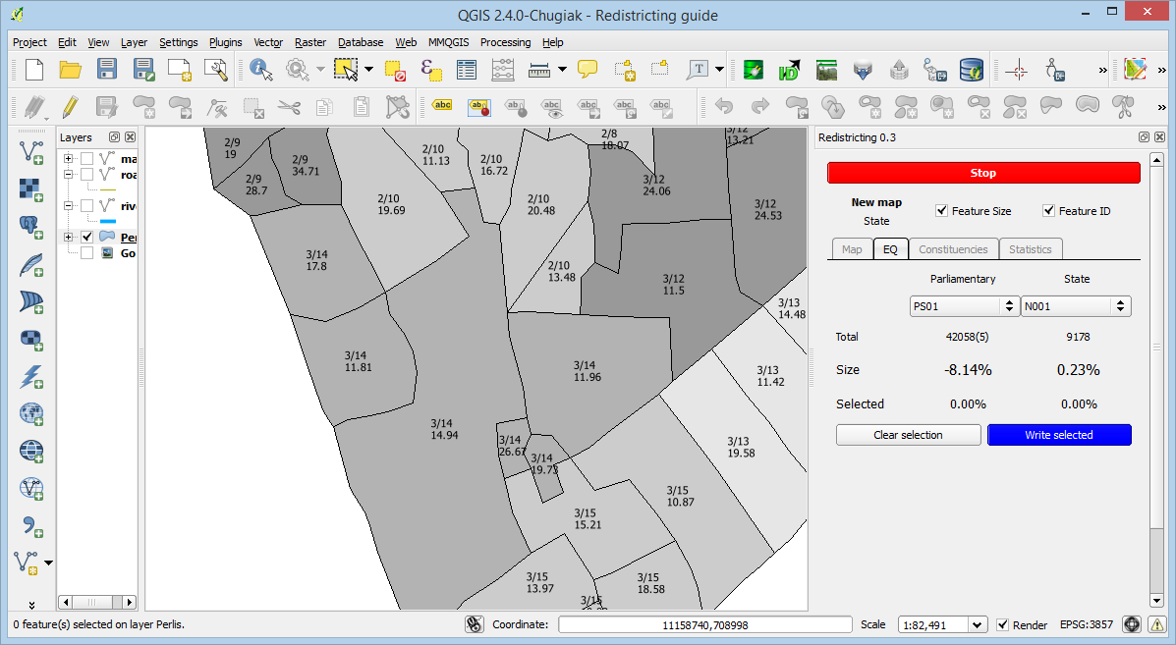

Repeat the above steps until Perlis is grey.

## Equalised Perlis

The following is Perlis equalised to within 10% for both parliamentary and state constituencies.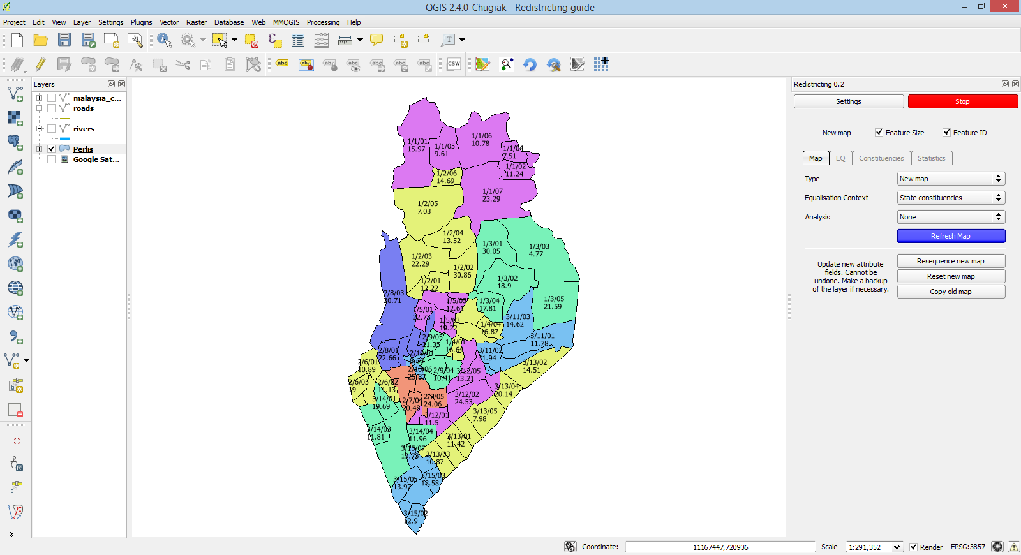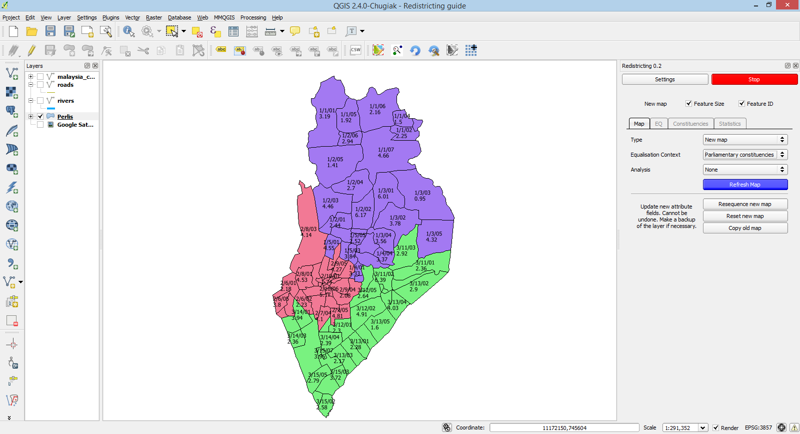

|  |  |
| --- | --- |
| Parliamentary range | -1.16% to 1.55% |
| State range | -6.86% to 5.05% |

## Equalisation Strategy

Delineation can either be done by

1. Starting from a clean slate and slowly allocation polling districts
2. Using the current map and swapping or moving polling districts between constituencies

### Clean Start

Start by allocating state constituencies until equalisation is reached

### Existing Start

In this scenario, we first equalise the parliamentary constituencies. Then, equalise state constituencies by only moving polling districts among the state constituencies within a parliamentary.

### Tips

1. Try using a smaller EQ to help identify oversized and undersized constituencies, eg. Try using 5% even though your goal is 10%. The plugin will help highlight outliers quickly.
2. If you’re blocked by very large polling districts, try to see if you can swap large polling districts so that the nett change is small.
3. If the recommendation engine suggests that you need to add more state seats, try reducing the size of your parliamentary constituency. Change your EQ to a tighter value to identify constituencies that you can shift polling districts too.

# Renumbering

When viewing the new map, you may have noticed that the feature ID does not display the polling district ID. This is because it is not relevant during equalising. This will only become a concern when exporting, printing or sharing your equalised map.

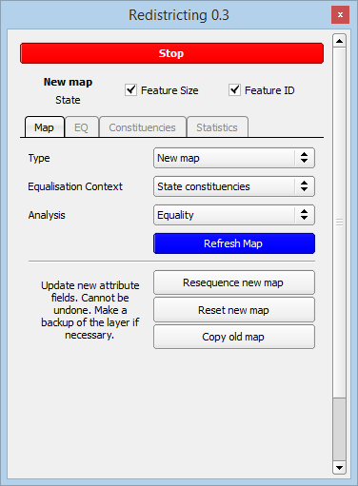

The “**resequence new map**” button is what you need to click. It helps regenerate the IDs of the new parliamentary, state and polling districts for you.

This is useful when the numbering for your constituencies are not ordered correctly. This will help you to save time during the equalisation process as you no longer have to concern yourself with getting the ordering right.

The following shows a renumbered[5] map.

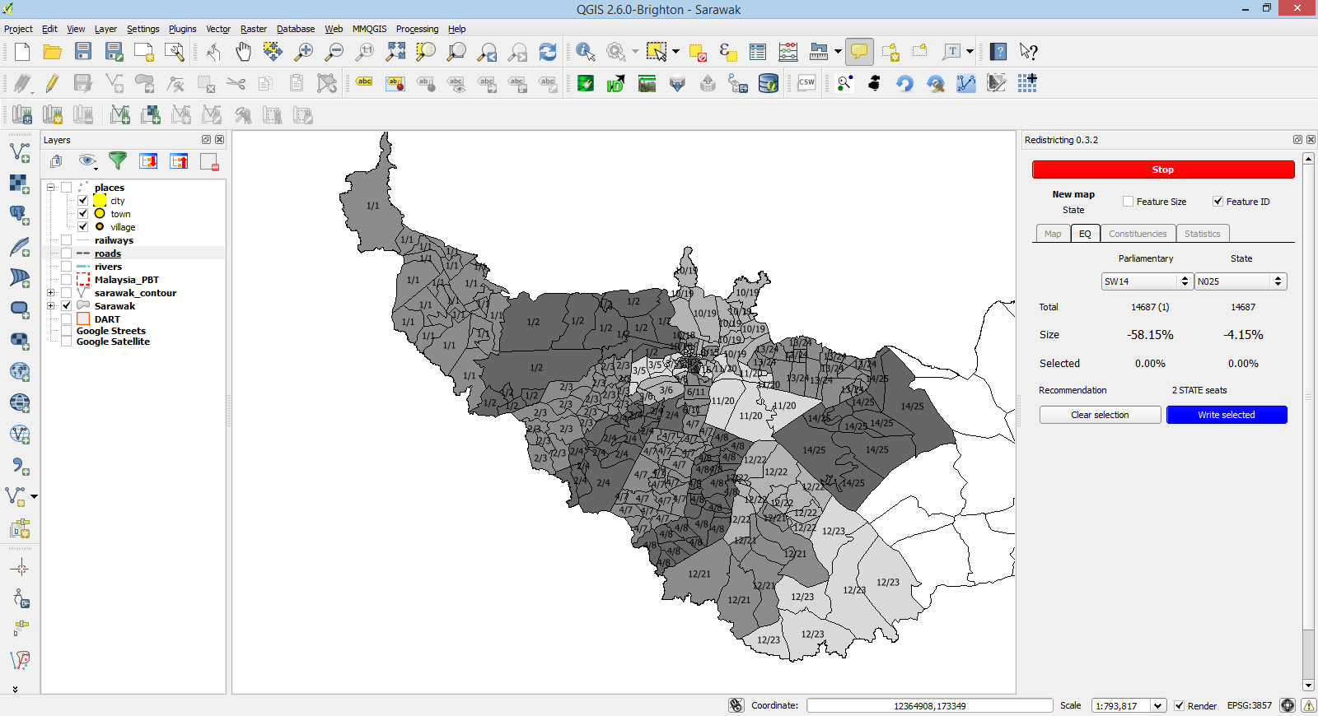

# Equalisation Metrics

Although the constitution only recommends that sizes of constituencies be roughly equal, there is also the concern of human bias that plays a big part in unfair delineations.

*“In the process of setting electoral districts, gerrymandering is a practice that attempts to establish a political advantage for a particular party or group by manipulating district boundaries to create partisan advantaged districts. When used to allege that a given party is gaining disproportionate power, the term gerrymandering has negative connotations.”[6]*

In Malaysia, racial gerrymandering tends to divide constituencies by race. In my opinion, racial gerrymandering encourages racism and it will play a major role in dividing the nation along racial boundaries. With mixed races in a constituency, representatives will be discourage from playing the race card to gain voter support.

## Circularity

To try achieve a roundish shape if possible. If a constituency has a very low circularity score, it will be suspected of being gerrymandered[7].

The exception will be for situations where the constituency is restricted by natural boundaries like mountain ranges or rivers leading to it having a strange snaky shape.

## Area size

If you’re constituency is too large to be easily accessible then you may want to consider swapping some large polling districts for a smaller polling district with a higher voter count.

Ultimately, how achievable this is depends on how the EC delineates polling districts.

# Appendix A

The following shows additional layers you could load to help with your equalization. You will need to set the layer blending to multiply.

## Administrative Boundaries (ISCGM)

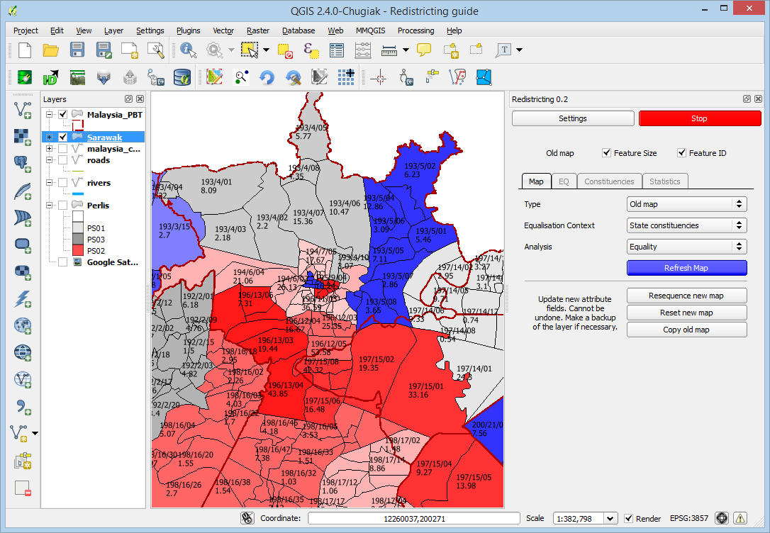

## Google Satellite

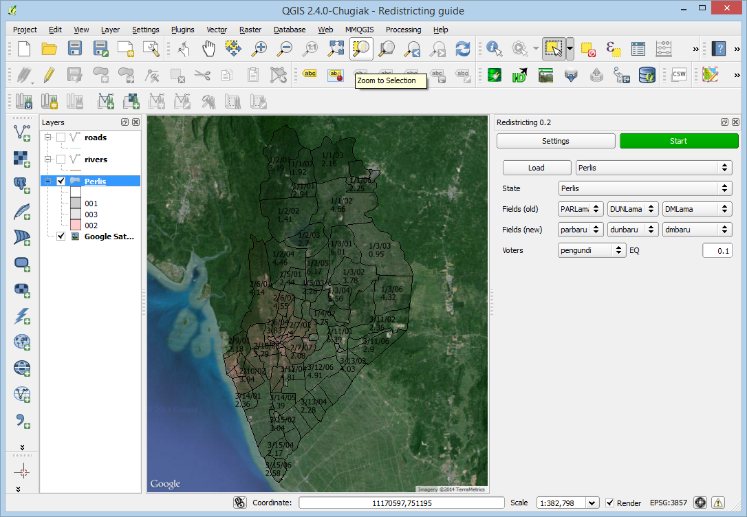

## Waterways (OpenStreetMap)

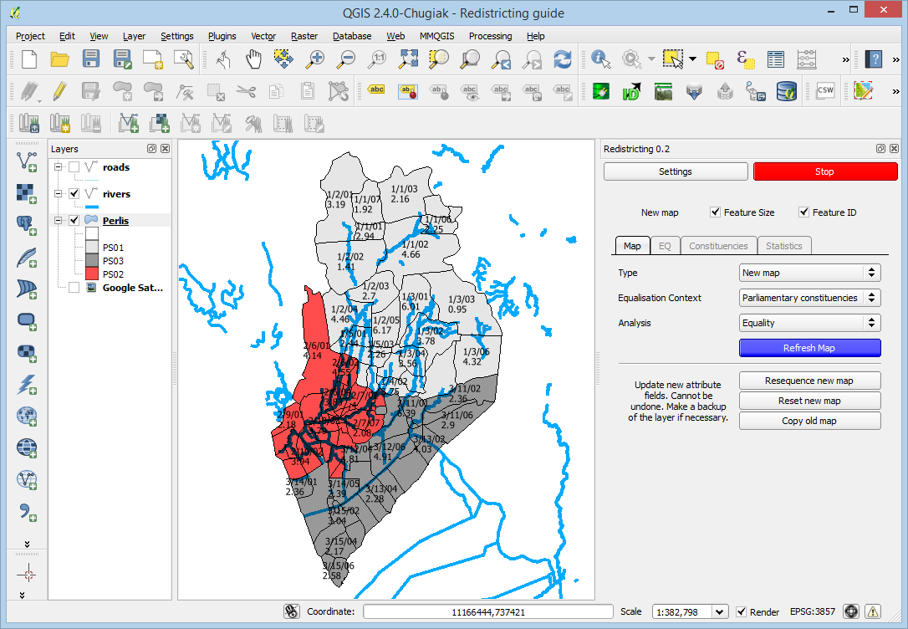

## Roads (OpenStreetMap)

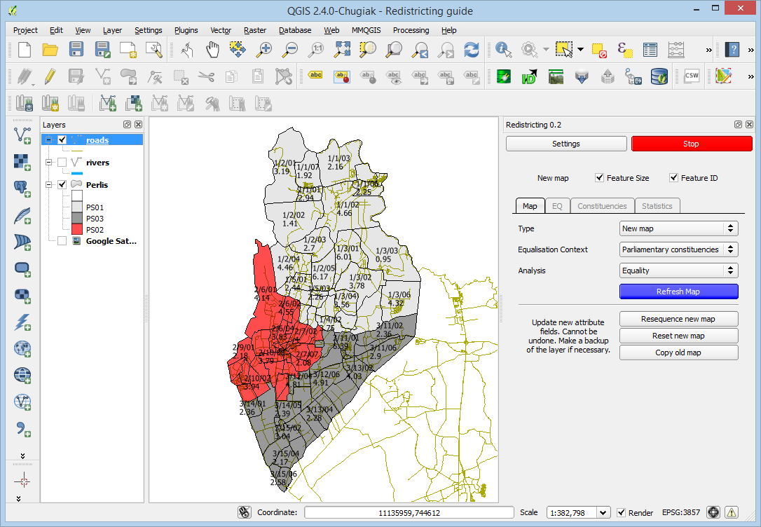

## Digital Elevation model (USGS GMTED)

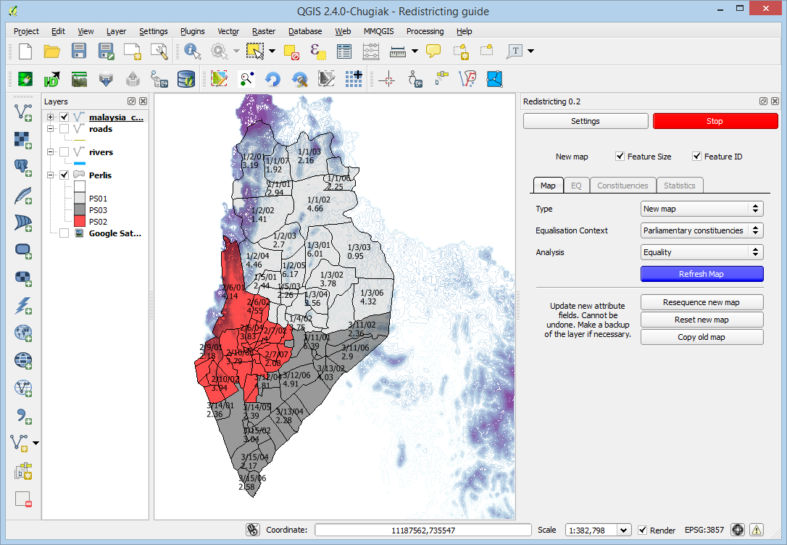

1. A shapefile is actually a collection of files accompanying a .shp file. Same filename but various different file extensions.
2. If not this, then try EPSG4326. Technically, East Malaysia uses EPSG3376 and West Malaysia, EPSG3375.
3. You can also pan the map by clicking and holding your mouse wheel button
4. Daerah mengundi
5. Renumbering currently works from left to right. A better method employing the use of an adjacency graph is coming (or not).
6. http://en.wikipedia.org/wiki/Gerrymandering
7. <http://www.redistrictingthenation.com/whatis-gerrymandering.aspx>